Stage 5 – Demented Carousel
COURSE DESIGNER: Adam Taylor

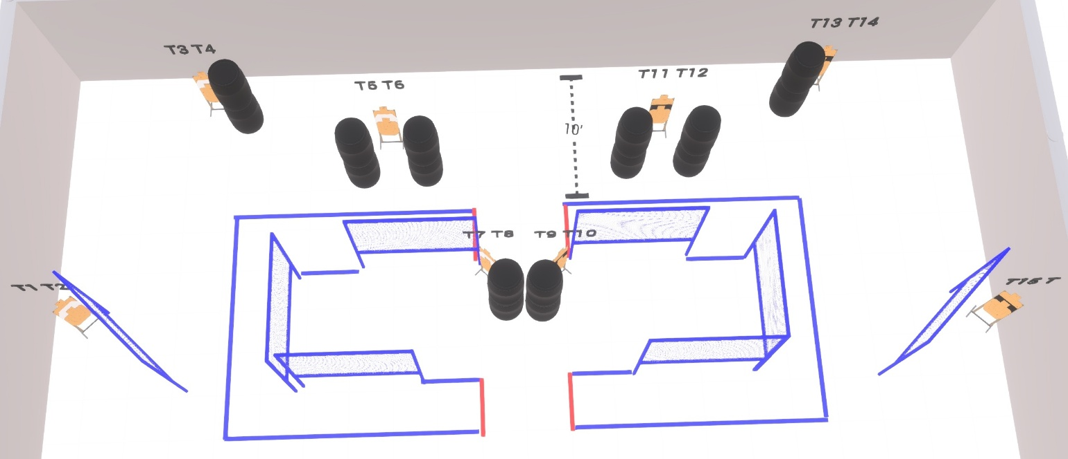

Written Stage Briefing:

Stage 5 – Demented Carousel - is a 32 round, 160 point, Comstock Course. There are 16 cardboard targets

Start position is straddling any red fault line
Handgun is loaded and holstered, wrists below belt
PCC is loaded, stock touching belt

On the audible start signal, engage targets from within the shooting area.

USPSA / NROI Range Commands:
- Make Ready
- Are you ready?
- Standby
- If finished, unload and show clear
- If clear, hammer down and holster (Handgun)
If clear, hammer down and flag (PCC)
If clear, cylinder closed and holster (Revolver)
- Range is clear

Setup Notes:
12 Single Wall Stands
8 Full Walls
8 Target stands / 16 target sticks
16+ Barrels



